Chapter 6: Inside the atom

Name: ______________________________ Date: _______________________

 | One of the particles inside the atom is very much lighter than the others. It is the:  - electron.  - neutron.  - nucleus.  - proton. | A | 1
 | The nucleus of the atom contains:  - only neutrons.  - only protons.  - electrons and neutrons.  - neutrons and protons. | D | 1
 | It was first suggested that all substances consisted of tiny, indestructible particles called atoms in:  - about 400 BC.  - 1808.  - 1911.  - 1983. | A | 1
 | The metal target that Rutherford used in his alpha scattering experiment was:  - radium.  - polonium.  - gold.  - silver. | C | 1
 | The number of isotopes of the element hydrogen is:  - 1.  - 2.  - 3.  - 4. | C | 1
 | The number of natural radioisotopes is approximately:  - 5.  - 50.  - 2000.  - 4000. | B | 1
 | Which particle is the heaviest?  - Beta  - Gamma  - Alpha  - Hydrogen | C | 1
 | The radioisotope used in smoke alarms is:  - Am-241.  - U-238.  - Sr-90.  - Na-24. | A | 1
 | Which of the following are atoms of the same element?  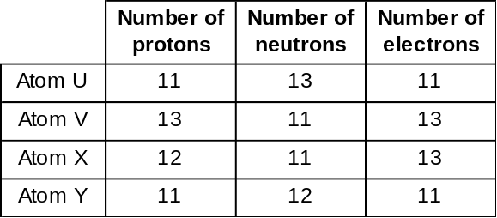  - U and Y  - U and X  - X and Y  - U and V | A | 1
 | Which of the following discoveries, or theories, about the atom came first?  - Electrons orbited the nucleus at different energy levels.  - The nucleus contained particles called neutrons.  - Most of the atom consisted of empty space.  - The electrons in the atom were embedded in the atom like the fruit in a plum pudding. | D | 1
 | Different isotopes of the same element contain different numbers of:  - electrons.  - neutrons.  - protons.  - nuclei. | B | 1
 | A radioisotope that is naturally present in the human body is:  - H-1.  - O-16.  - K-40.  - Am-241. | C | 1
 | The technique used to determine the age of a fossil is:  A. radiometric dating.  B. nuclear fission.  C. radiotherapy.  D. brachytherapy. | A | 1
 | A 1 kg sample of pure iron-59 is left in a safe container for 46 days. When placed on an electronic balance, its mass is found to be only 500 grams. The half-life of iron-59 is:  - 23 days.  - 46 days.  - 59 days.  - 92 days. | B | 1
 | Which of the following radioisotopes is used as a fuel in nuclear reactors?  - Barium-137  - Cobalt-60  - Iron-59  - Uranium-235 | D | 3
 | The process of nuclear fission, which takes place in a nuclear power station, occurs when:  - two nuclei merge with each other to form a new, larger nucleus.  - one nucleus splits to form two or three smaller nuclei after absorbing a neutron.  - neutrons are fired at a large nucleus, splitting it into hundreds of smaller nuclei.  - protons are fired at a large nucleus at high speed, splitting it in two. | B | 3
 | Which of the following radioisotopes is used in the radiation treatment of cancer?  - Carbon-14  - Cobalt-60  - Plutonium-239  - Uranium-235 | B | 3
 | A radioisotope has a half-life of 1000 years. What percentage of the original amount would be left after 3000 years? | 12.5% (after 3 half-lives) | 2
 | What makes the nuclei of some atoms naturally unstable? | The neutrons and protons are not held together as strongly as in other atoms. | 3
 | Identify three radioisotopes from this list that are synthetic.  - Plutonium-239  - Carbon-14  - Uranium-238  - Curium-244  - Berkelium-249  - Hydrogen-3 | - Plutonium-239  - Curium-244  - Berkelium-249 | 3
 | Describe how Becquerel discovered radioactivity. | He placed some uranium salts in a drawer near some undeveloped photographic plates. When he went to use the plates he found they were all foggy as they had been exposed. The radiation from the uranium had done the damage. | 2
 | The following graph shows the decay rate of a radioactive element. Estimate the half-life of this radioisotope.  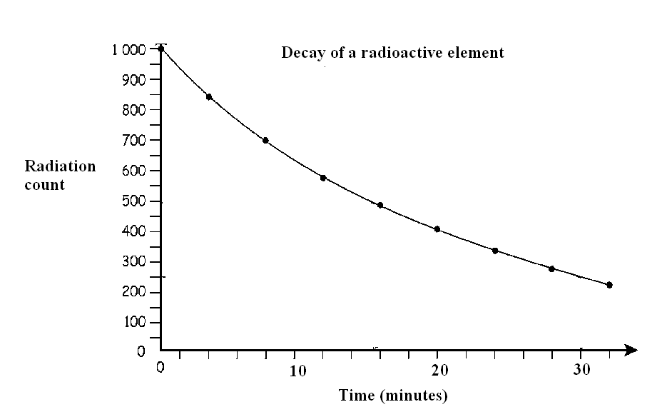 | About 15 minutes. When the count reaches 250, or 25%, the time elapsed is 30 minutes; thus, two half-lives is 30 minutes and one half-life is 15 minutes. | 1
 | The following are statements about the advantages and disadvantages of using nuclear power. Identify by code letter those statements that show the advantages of uranium as a nuclear energy source.  - Australia has vast uranium deposits.  - Storage of wastes is expensive and potentially dangerous.  - Incredibly powerful — good energy output per gram of fuel  - Mining of ore upsets the environment.  - Fear of meltdown or nuclear accident — possible health hazard  - No atmospheric pollution in comparison to coal | A , C, F | 3
 | Iodine is concentrated by the body in the thyroid gland. Why would a doctor use I-131 radioisotope (half-life = 8 days) during an investigation of the thyroid gland in the neck and not a longer-lived isotope? | It decays very quickly and does not pose a long-term radiation exposure risk to the patient. | 2
 | Consider the following cartoon.    - Identify the historical experiment represented by this cartoon.  - Explain the meaning of this cartoon. | - Rutherford’s discovery of the nucleus  - The bullets represent alpha particles fired at an atom. Occasionally, an alpha particle hits the very small nucleus and bounces off. The tissue represents the largely empty space of the atom. | 3
 | Volcanic ash collected from Olduvai Gorge in East Africa tells us the age of fossil remains of two primitive human-like animals, Zinjanthropus and Homo habilis, to be about 1 750 000 years old.  - Explain why carbon-14 dating cannot be used to estimate the age of these fossils.  - Other radioisotopes are found in the volcanic ash. These are:  Strontium-90: half-life 28 years  Aluminium-26: half-life 720 000 years  Rubidium-87: half-life 46 000 000 000 years.  Identify which radioisotope could be used to determine the age of the ash and, therefore, the fossils. | - Carbon-14's half life (5730 yrs) is too short and all the C-14 in the fossils would have decayed.  - Al-26. If the fossils are 1 750 000 years old then there will still be a significant percentage of Al-26 remaining as it has a much longer half-life than C-14. | 3
 | If a radioactive element has a long half-life would it pose more or less danger if it was released into our environment? Explain your answer. | A radioactive element that has a long half-life would remain in the environment longer and would possibly cause damage over a longer period of time. | 2
 | The graph below shows the radioactive decay of iodine-131.  - What is the half-life of iodine-131?  - How many radioactive particles would be left after 40 days?  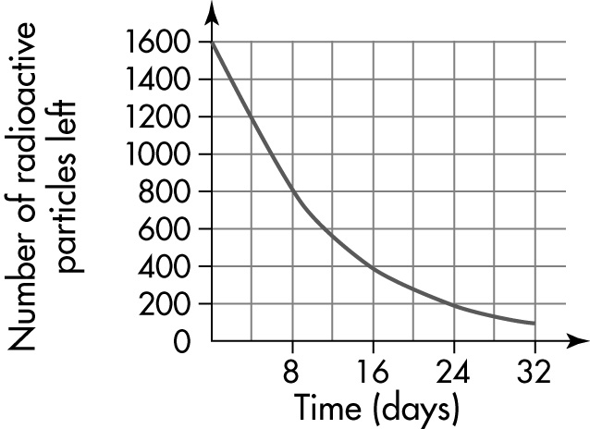 | - 8 days  - 50 | 2
 | List two major long-term effects on humans caused by cell damage resulting from exposure to large amounts of nuclear radiation. | Two of the following: cancer, leukaemia, birth defects | 2
 | The used fuel rods in a nuclear reactor are radioactive.  - How are they currently disposed of?  - Why is it important to find a more permanent solution to the problem of disposing of nuclear waste? Give two reasons. | - They are sealed in steel or glass containers and buried deep at sea or underground, or stored in power stations.  - Two of the following: some radioisotopes in nuclear waste last thousands of years; storage containers could corrode and leak; if the ground is unstable storage containers could break open during earthquakes. (Other answers are also possible.) | 4
 | Construct a small concept map using at least eight ideas about the structure of the atom. | Answers will vary. | 4

